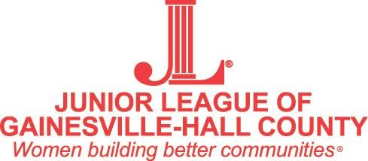

2019 – 2020 Provisional Member Calendar

AUGUST 2019
- August 20th - New Member Kick Off Dinner and Thrift Sale
SEPTEMBER 2018
- September 3rd - General Membership Meeting
- September 17th - New Member Class Meeting (Diaper Bank)
OCTOBER 2018 (NO Meetings)
- September 29th - October 2nd General Work shift
- October 3rd - Sustainer Coffee 9:30- 1
- October 3rd - Double Price Shopping 4:30- 8
- October 5th - Sale Day 8:30- 2
NOVEMBER 2018
- November 5th - General Membership Meeting
- November 19th - New Member Class Meeting (Feeding Our Future)
DECEMBER 2018
- December 3rd - General Membership Meeting (Christmas Party)
- December 14th - Charity Ball
- December 17th - New Member Class Meeting (Christmas Exchange) (Location TBD)
JANUARY 2019
- January 7th - General Membership Meeting
FEBRUARY 2019
- February 4th - General Membership Meeting
MARCH 2019
- March 3rd - General Membership Meeting
- March 17th - New Member Class Meeting
APRIL 2019
- April 7th - General Membership Meeting
- April 21st - New Member End of the Year Dinner (Location TBA)
MAY 2019
- May 5th - May Dinner

NEW MEMBER CLASS RESPONSIBILITIES

Members of the 2019-2020 New Member Class will be expected to:

- Attend a minimum of 5 out of 8 monthly General Membership Meetings
Meetings are held on the first Tuesday of each month, September 2019 – May 2020, except October, at 6:30 p.m. at the Junior League Lodge.

- Attend a minimum of 4 out of 5 New Member Class Meetings
Between August 2019 – May 2020. Meetings will be held on the third Tuesday of each month at 6:30 at the Junior League Lodge unless noted for a different location.

- Serve on a committee and work a sale day shift for Thrift Sale.
Held the first weekend in October (Thrift Sale information TBA).

- Complete one “Done in a Day Project” designated by the Junior League for a local non-profit agency. This year members will be able to sign up with the Active Members by email or at the General Membership Meetings.

- Pay dues of $350, which includes two tickets Charity Ball, dues to AJLI, and a ticket to May Dinner 2020.
- Pay in Full Deadline - May 31st
- Split Payment
  - 1st Payment Deadline - May 31st
  - 2nd Payment Deadline - August 31st
- Grace period of 2 weeks is given at which point members are dropped until
reinstated with a fee
- Early withdrawal refund policy - AJLI portion of dues is non-refundable. Any
other refunds are at the discretion of the board.

If at any time a New Member finds that she is unable to complete the New Member requirements, she may resign in good standing and may be reinstated to complete the course another year.

Mission Statement
The Junior League of Gainesville-Hall County, Inc is an organization of women committed to promoting voluntarism, developing the potential of women and improving the community through the effective action and leadership of trained volunteers. Its purpose is exclusively educational and charitable.

Vision Statement
The Junior League of Gainesville-Hall County is committed to making Northeast Georgia a better place for children and families. Acting as a catalyst for positive change, we seek new opportunities to impact our community.

